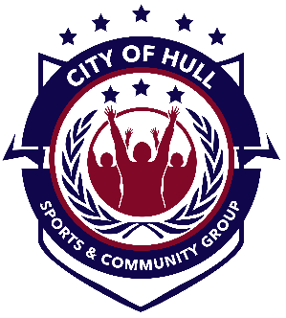
Equality Policy Statement
City of Hull Sport & Community Group are an organisation committed to ensuring that equality is incorporated in all aspects of coaching delivery and the development of the coaches, volunteers, staff and participants. In pursuing this, City of Hull Sport & Community Group acknowledges and adopts the following Sport England definition of Sports Equality:
“Sports equality is about fairness in sport, equality of access, recognising inequalities and taking steps to address them. It is about changing the culture and structure of sport to ensure it becomes equally accessible to everyone in society”.
City of Hull Sport & Community Group C.l.C. will:
- Ensure that all people irrespective of their age, gender, ability, race, religion, ethnic origin, creed, colour, nationality, social status or sexual orientation have a genuine and equal opportunity to participate in the centres sessions at all levels and in all roles.

- No disadvantage any individual by imposing any conditions or requirements which can not be justified.

- Provide clear advice and opportunities for training to all those working for or on behalf of the club.

- Ensure that all those who participate in the sessions at all levels and all roles receive a fair and equal treatment.

- Ensure that anybody working or wishing to work for or on behalf of the club does not receive less favourable treatment on the grounds outlined in the policy statement.
City of Hull Sport & Community Group C.l.C. expects all those acting on behalf of City of Hull Sport & Community Group C.l.C.:
- To adopt to the principles set out in this policy
- To actively oppose discriminatory behaviour
- To promote equality of opportunity
Any employee of City of Hull Sport & Community Group C.l.C. found to be failing to comply with any of the points set out in this statement may face disciplinary action.

Signed:

Position:

Date: Review Date:

